**ASSIGNMENT 1 (VIJAY-SINGH-RATHORE)**

**DASHBOARD- BIT7**

1. Power BI Installation

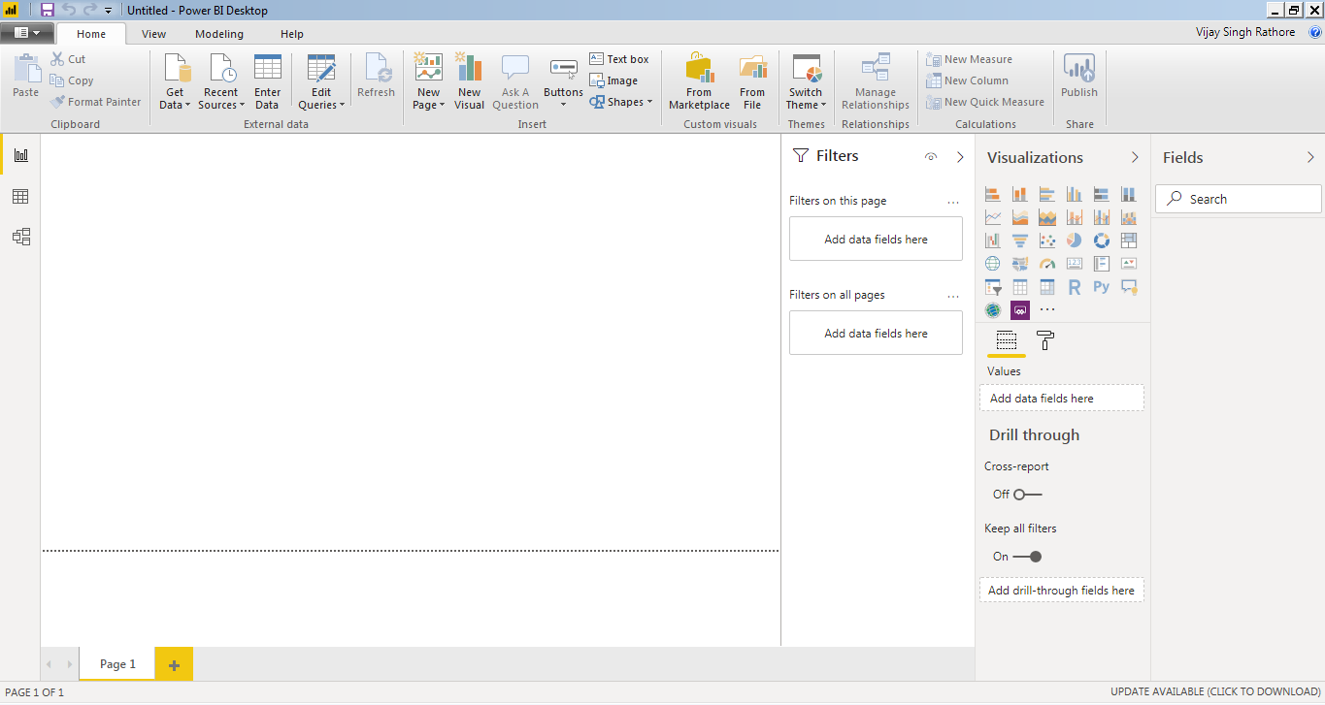

2. (i) Report view

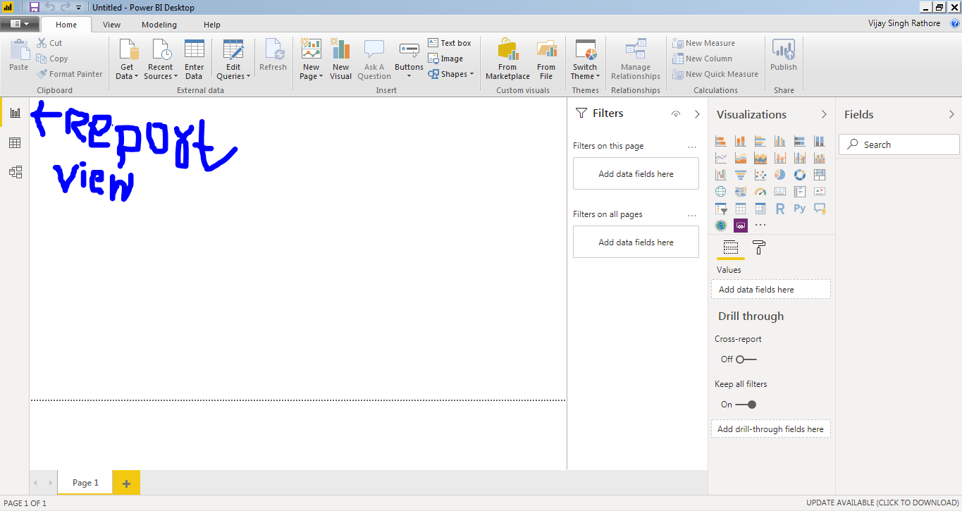

2(ii). Data view

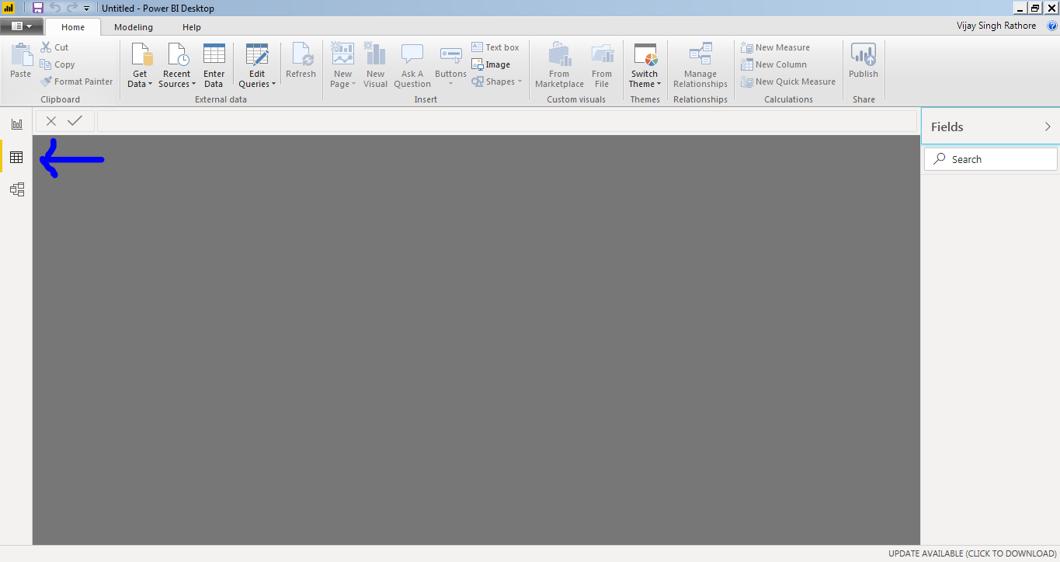

2(iii). Model view

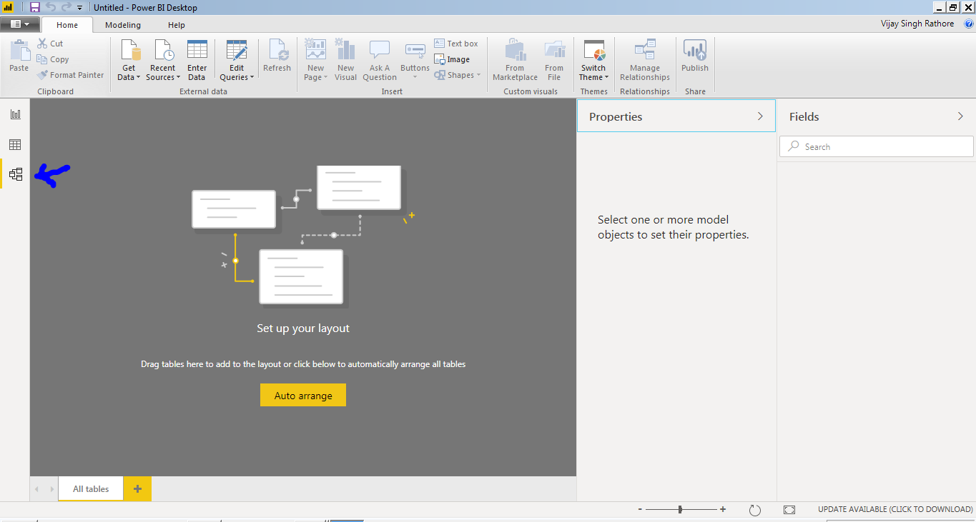

2(iv). Power query editor

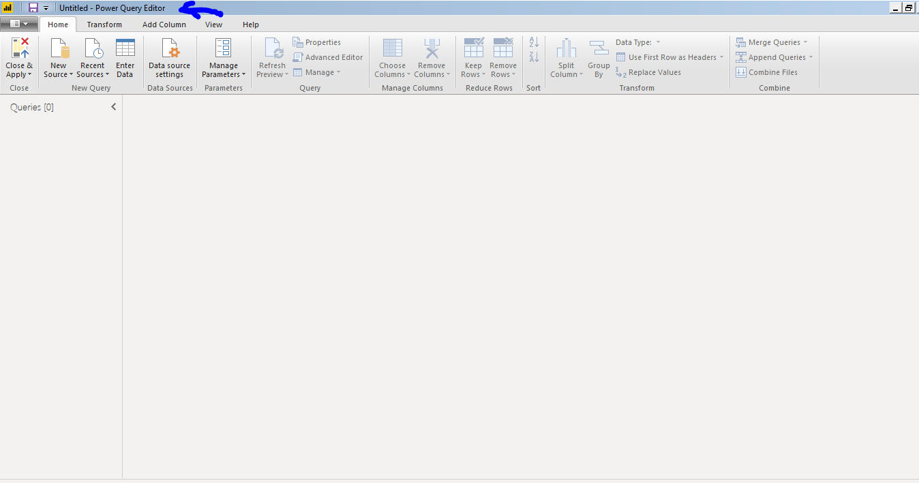

2(v). Advanced editor

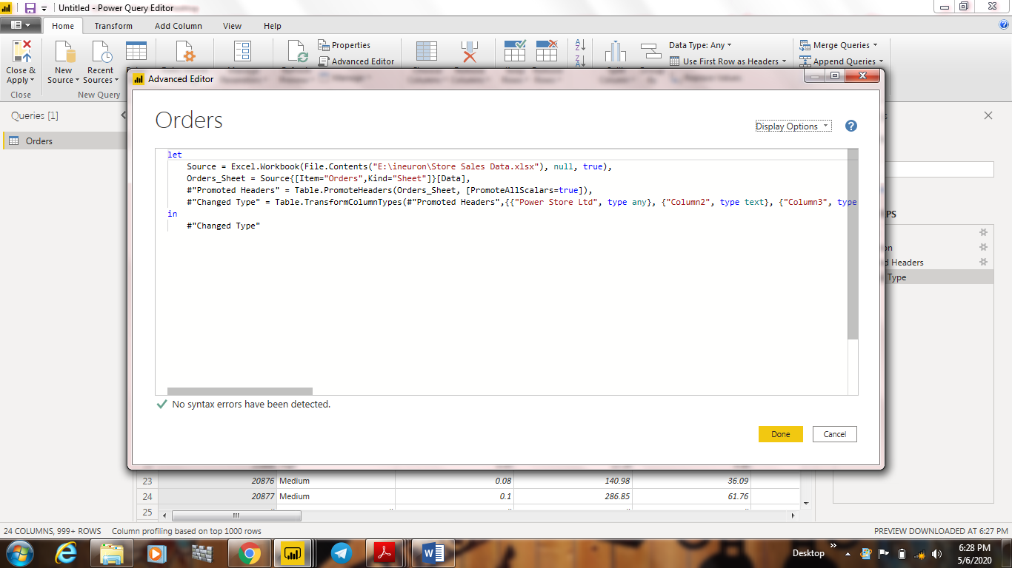

3. Prices of different versions of power bi:-

(i) Power BI desktop-FREE FOR LIFETIME.

(ii) Power BI PRO-$9.99/month.

(iii) Power BI Premium-$4995/month.